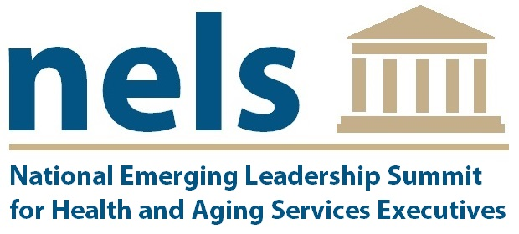

The 2018 National Emerging Leadership Summit Application
July 17 – 19, 2018
Washington, D.C.

Name:
Organization:
Title:
Mailing Address:
City, State, Zip:
Email Address: |  | Phone:
Gender: |  | State of Practice:
Age: |  | Years in Practice:

APPLICATION CHECKLIST:
- One-page statement outlining your experience as a health and aging services administrator, including your commitment to long-term care
- Resume
- One (1) professional letter of reference
- Professional biography (no more than 200 words)

DEADLINE TO APPLY: Friday, May 18, 2018

Applicants will be notified within two (2) weeks of application deadline of acceptance to the Summit. Upon acceptance, information regarding registration fee payment and hotel reservations will be provided.

For more information, please contact:
Kevin Hansen, NELS Director Doug Olson, NELS Senior Advisor
hansekev@uwec.edu olsondou@uwec.edu
(715) 836 – 3149 (715) 836 – 5067

The NELS Summit is targeted toward executives and professionals in health and aging services who typically have been in the field for under ten years and are identified as emerging leaders by others in their organization or company. The Summit aims to increase, improve, and support the profession to attract talented future leaders by giving a voice to the next generation of leaders. Individuals that have attended the Summit hold positions in skilled nursing facilities, nursing homes, assisted living facilities, continuing care retirement communities, rehabilitation hospitals, home- and community-based services, and affiliated organizations across the country.

Over the course of the Summit’s three days, participants will:
- Identify, develop, and refine solutions for the next generation of leaders, building on themes from the previous years’ emerging leaders;
- Meet with representatives of key professional and trade organizations, gaining an inside perspective on the legislative and advocacy processes; and
- Engage in discussions with other leaders in the field of health and aging services administration to advance an agenda of action.

The Summit package* registration fee includes:
- Daily breakfast and lunch provided
- Evening social at the host hotel
- Washington, D.C. evening event**
- Three days with Summit leadership and participants, including time at the U.S. Capitol
- Approximately 16 NAB-approved continuing education units (CEs)
- Cost: $985/participant

For more information, please visit:
http://www.nelssummit.org

We are very grateful to our co-sponsors for the NELS Summits:
